Williams County Abstract Company
PO Drawer F ~ Williston, North Dakota 58801

Phone: 701-572-3381

Fax: 701-572-8068
E-Mail: Abstract@WilliamsAbstract.com

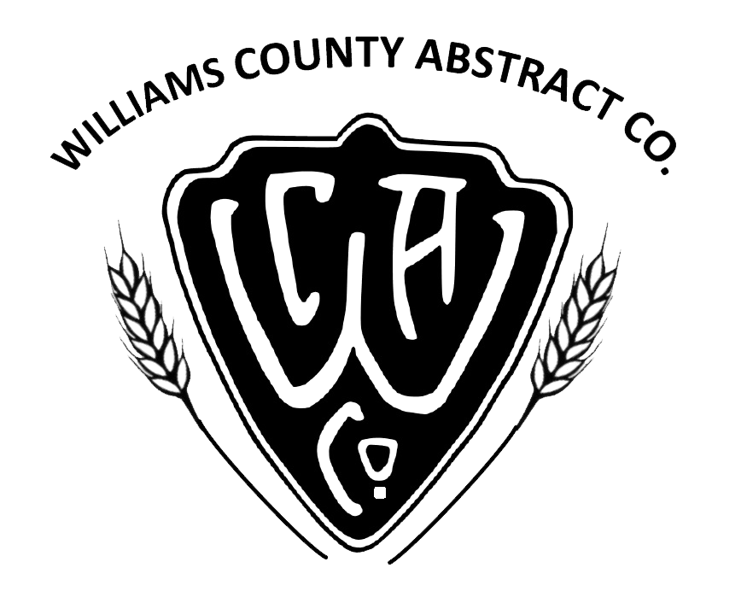

ABSTRACT OF TITLE ORDER FORM

NOTE: This form is to order only an Abstract of Title. If you need to order other title services, such as Title Insurance, Closing or other services, please fill out the appropriate form.
Give us a call if you are unsure which is the right one and we will happily guide you along!

Date of Request: ____________________________________________________________

Ordered by Name: ____________________________________________________________

Mailing Address: ____________________________________________________________

Phone Number: ____________________________________________________________

E-mail Address: ____________________________________________________________

PROPERTY INFORMATION

Record Title Owner of Property: ____________________________________________________________

Legal Description: ____________________________________________________________

____________________________________________________________

Property Address: ____________________________________________________________

Do you need an Attorney’s Opinion: YES NO (circle one)

Additional Information: ______________________________________________________________________

__________________________________________________________________________________________

__________________________________________________________________________________________

__________________________________________________________________________________________

